Article: Building a Password Generator Using Python and Tkinter

Title: Enhancing Security with a Custom Password Generator

Introduction:
In this article, we will explore how to build a password generator using Python and Tkinter. Security is of paramount importance when it comes to system integrity, and using highly secure passwords is crucial for protecting user-level access. Highly secure passwords should not be easily predictable, such as using surnames or dates of birth. Therefore, we can create a simple password generator that generates random passwords and allows us to conveniently copy them to the clipboard. In this project, we will leverage the random module to generate random characters, the Tkinter library to create a user-friendly GUI window with necessary fields, and the Pyperclip library to manipulate clipboard contents. You can download the source code here

Step 1: Importing the Required Libraries:
To begin, we import the necessary libraries:
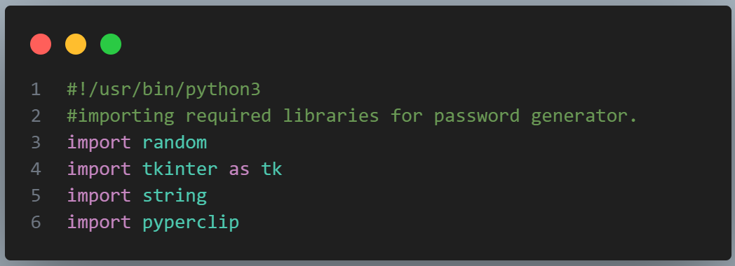
- The `random` module, which enables us to generate random numbers, select random elements, and shuffle sequences.
- The `string` module, which provides a collection of useful constants and functions for working with strings.
- The `tkinter` library, which allows us to develop graphical user interfaces (GUIs) for interacting with the password generator.
- The `pyperclip` library, which provides a cross-platform interface to the clipboard, allowing us to programmatically access and manipulate its contents.

Step 2: Creating the GUI Window:
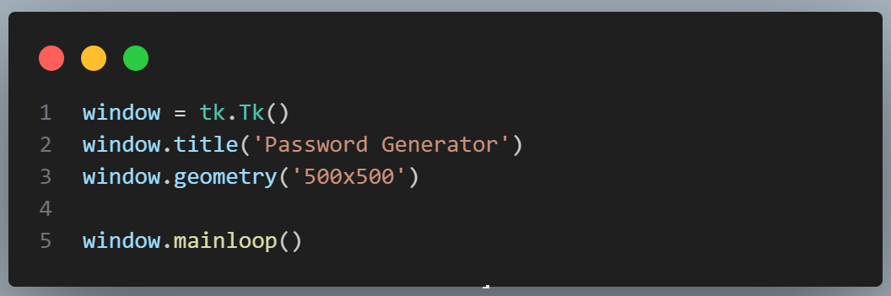
We create a GUI window using Tkinter. We initialize a new Tkinter window object named `window` with the `tk.Tk()` function. Then, we set the window title using the `title()` method and its dimensions using the `geometry()` method. Finally, we start the main event loop of the Tkinter window using the `window.mainloop()` function, ensuring it remains open until the user closes it.

Step 3: Creating the `password_generator()` Function:
The `password_generator()` function generates a random password by selecting a character from each category (digits, letters, punctuation) and then randomly selecting the remaining characters from the combined valid characters. The generated password is displayed in the `password_see` widget.
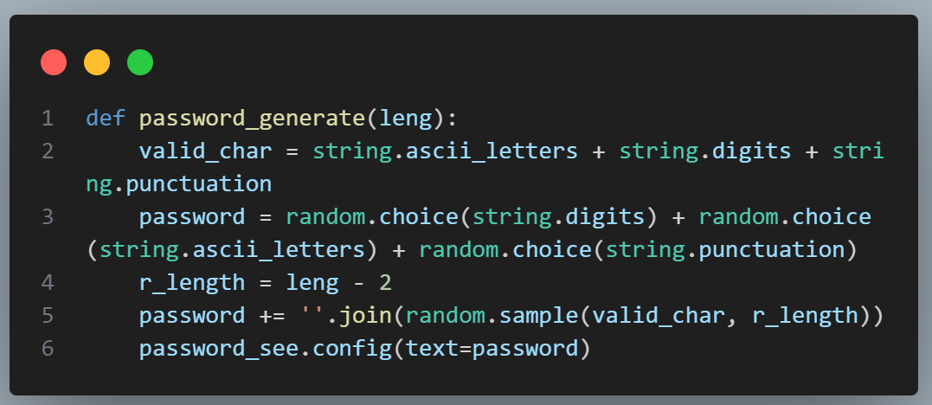
Inside the function, we define a string named `valid_char`, which contains all the valid characters for the password. It includes uppercase letters, lowercase letters, digits, and punctuation marks. We then define the `password` in two parts. The first part randomly selects one unique character from each of the three categories (digits, letters, punctuation) and concatenates them to form the starting characters of the password. The second part (`password += ''.join(...)`) generates the remaining characters by using `random.sample()` to randomly select `r_length` characters from the `valid_char` string without replacement. The selected characters are then joined and appended to the existing password.

Step 4: Creating the `copy_password()` Method:
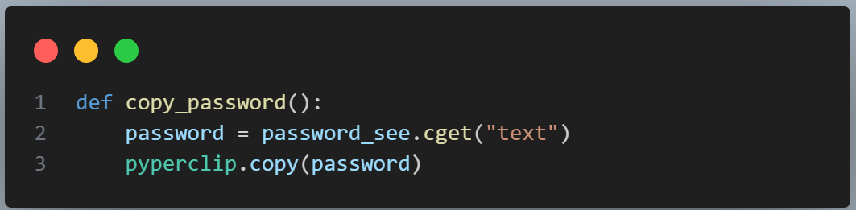
The `copy_password()` function is defined to copy the password displayed in the `password_see` label to the clipboard. It first retrieves the text value of the `password_see` label using the `cget()` method with the argument `"text"`. The retrieved password is then copied to the clipboard using the `copy()` function from the `pyperclip` module. This allows the user to easily copy the generated password and paste it into other applications or fields as needed.

Step 5: Function to Get the Password Length:
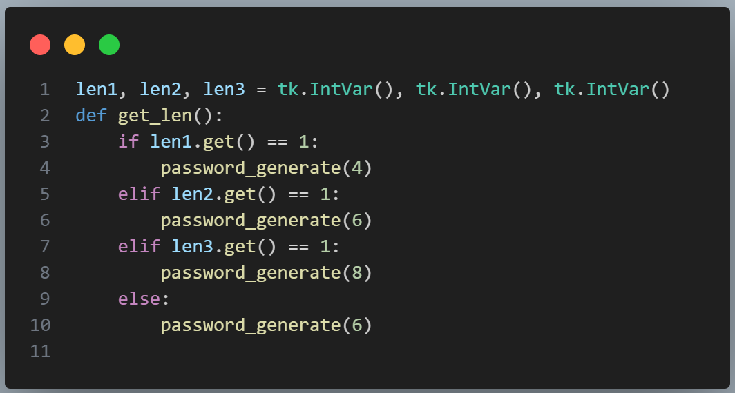
We create instances of `IntVar` named `len1`, `len2`, and `len3` using multiple assignment. Each variable is assigned a new instance of `tk.IntVar()`, a class in the Tkinter module for storing integer values. The `get_len()` function checks the values of `len1`, `len2`, and `len3` using their `get()` method and uses `if-else` statements to determine which checkbox is selected. Based on the selected checkbox, the function calls the `password_generator()` function with the appropriate length.

Step 6: Creating Checkboxes:
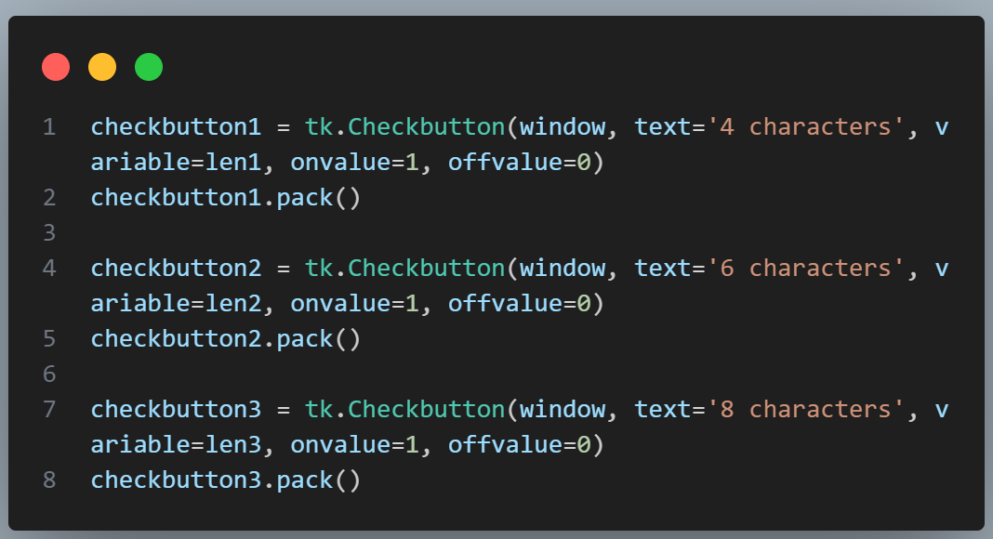
We create three checkboxes (4 characters, 6 characters, and 8 characters) to allow the user to choose the length of the password. Each checkbox is assigned a variable name and a value so that when a checkbox is selected, it performs the desired task. The checkboxes provide the user with options for password length.

Step 7: Creating Generate Button, Copy Button, and Copy Label:
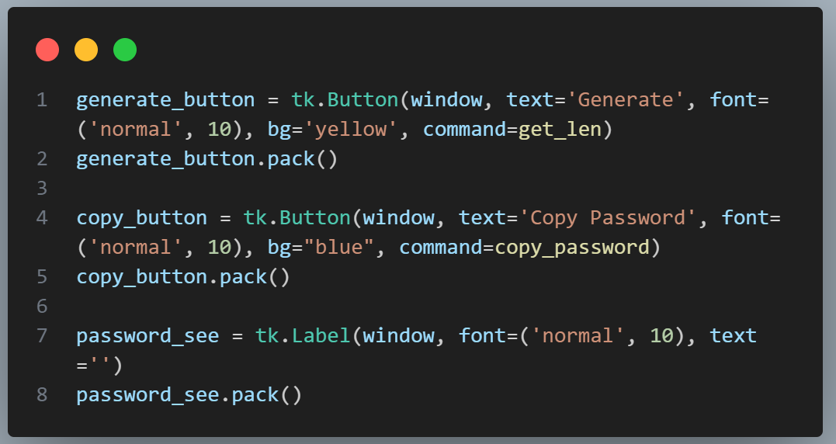

To enhance the functionality of the password generator, we incorporate additional components into the GUI interface. The `password_see` label is created using the `Label` class from Tkinter, configured with a normal font of size 10 and an empty text. By calling `password_see.pack()`, `copy_button.pack()`, and `generate_button.pack()` the label is added to the window's layout. Additionally, we introduce the `copy_button` widget, a button displaying the text "Copy Password". This button is defined using the `Button` class, customized with a normal font of size 10 and a blue background. The `command` parameter is set to the `copy_password` function, ensuring its execution when the button is clicked. Lastly, the `generate_button` is created using the `Button` class, featuring the text "Generate". It has a normal font of size 10 and a yellow background. The `command` parameter is set to the `get_len` function, enabling password generation when the button is clicked.

Conclusion:
In this article, we have explored how to create a random password generator using Python and Tkinter. The application provides users with the ability to generate strong passwords of varying lengths and copy them to the clipboard for convenience and security. By leveraging Python's randomization capabilities, string manipulation, and the Tkinter GUI toolkit, we have developed a functional and user-friendly password generator. This project serves as a great introduction to building GUI applications and showcases the power and versatility of Python as a programming language.

